**Name: Bhumika Maharjan**

**Roll No : 22081027**

**Q14. Solution of RBD**

**Working expression:**

FT =MST/MSE

FB =MSB/MSE

MST = SST/a −1

MSB = SSB/b−1

MSE= SSE/(a−1)(b−1)

**Working procedure:**

Analyze → General linear model → Univariate → Put values in the dependent variable →

Put block and treatment in fixed factors → Click model → Go to custom → Block and

treatment in factor and covariates send to model → Type main effects → Sum of square

type III → continue → click post Hoc → Send block and treatments in factors in Post Hoc

tests for → click LSD → continue → ok → Copy only ANOVA table in word file.

**SPSS Output :**

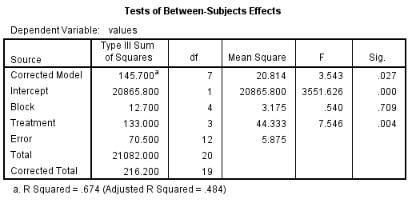

**Testing procedure:**

**Setting up Hypothesis:**

H0: There is no significance difference between treatments and blocks

H1: There is significance difference between treatments and blocks

Level of significance:

α=0.05

**Decision:**

For treatment, p = 0.004 < α = 0.05, Hence we accept H1 and H0 is

rejected

For block, p = 0.709 > α = 0.05, Hence we accept H0 and H1 is rejected

**Conclusion:**

Hence, we conclude that there is significant difference between treatments

but there is no significant difference in blocks.

**Name: Bhumika Maharjan**

**Roll No: 22081027**

**Q15. Solution of RBD**

**Working expression:**

FT =MST/MSE

FB =MSB/MSE

MST = SST/a −1

MSB = SSB/b−1

MSE= SSE/(a−1)(b−1)

**Working procedure:**

Analyze → General linear model → Univariate → Put values in the dependent variable →

Put block and treatment in fixed factors → Click model → Go to custom → Block and

treatment in factor and covariates send to model → Type main effects → Sum of square

type III → continue → click post Hoc → Send block and treatments in factors in Post Hoc

tests for → click LSD → continue → ok → Copy only ANOVA table in word file.

**SPSS Output :**

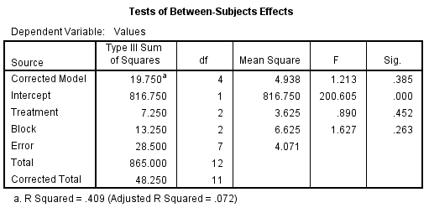

**Testing procedure:**

**Setting up Hypothesis:**

H0: There is no significance difference between treatments and blocks

H1: There is significance difference between treatments and blocks

Level of significance:

α=0.05

**Decision:**

For treatment, p = 0.452 > α = 0.05, Hence we accept H0 and H1 is

rejected

For block, p = 0.263 > α = 0.05, Hence we accept H0 and H1 is rejected

**Conclusion:**

Hence, we conclude that there is no significant difference in blocks and treatment.

**Name: Bhumika Maharjan  
Roll No: 22081027**

**Q.16: Solution of LSD**

**Working expression:**

FR =MSR/MSE MSR =SSR/m −1

FC =MSC/MSE MSC =SSC/m−1

FT =MST/MSE MST =SST/m−1

MSE= SSE/{(m−1)(m−2)}

**Working procedure:**

Analyze → General linear model → Univariate → Put values in the dependent variable →

Put row, column and treatment in fixed factors → Click model → Go to custom → row,

column and treatment in factor and covariates send to model → Type main effects → Sum

of square type III → continue → click post Hoc → Send row, column and treatment in

factors in Post Hoc tests for → click LSD → continue → ok → Copy only ANOVA table in

word file

**SPSS Output :**

|  |  |  |  |  |  |
| --- | --- | --- | --- | --- | --- |
| **Tests of Between-Subjects Effects** | | | | | |
| Dependent Variable: Values | | | | | |
| Source | Type III Sum of Squares | df | Mean Square | F | Sig. |
| Corrected Model | 675.141a | 12 | 56.262 | 2.228 | .090 |
| Intercept | 53305.574 | 1 | 53305.574 | 2111.078 | .000 |
| row | 139.810 | 4 | 34.952 | 1.384 | .297 |
| column | 183.966 | 4 | 45.991 | 1.821 | .190 |
| treatment | 351.366 | 4 | 87.841 | 3.479 | .042 |
| Error | 303.005 | 12 | 25.250 |  |  |
| Total | 54283.720 | 25 |  |  |  |
| Corrected Total | 978.146 | 24 |  |  |  |
| 1. R Squared = .690 (Adjusted R Squared = .380) | | | | | |

**Testing Procedure:**

**Setting of hypothesis:**

H0: There is no significance difference between rows, columns and

treatments

H1: There is significance difference between rows, columns and treatments

**Level of significance**

α=0.05

**Decision**

For row, p = 0.299 > α = 0.05, Hence we accept H0 and H1 is rejected

For column, p = 0.197 > α = 0.05, Hence we accept H0 and H1 is rejected

For treatment, p = 0.042 < α = 0.05, Hence we accept H1 and H0 is

rejected

**Conclusion:**

Hence, we conclude that there is no significant difference between rows

and columns but there is significant difference in treatments

**Name: Bhumika Maharjan**

**Roll No :22081027**

**Q17. Solution of LSD**

**Working expression:**

FR =MSR/MSE MSR =SSR/m −1

FC =MSC/MSE MSC =SSC/m−1

FT =MST/MSE MST =SST/m−1

MSE= SSE/(m−1)(m−2)

**Working procedure:**

Analyze → General linear model → Univariate → Put values in the dependent variable →

Put row, column and treatment in fixed factors → Click model → Go to custom → row,

column and treatment in factor and covariates send to model → Type main effects → Sum

of square type III → continue → click post Hoc → Send row, column and treatment in

factors in Post Hoc tests for → click LSD → continue → ok → Copy only ANOVA table in

word file.

**SPSS Output :**

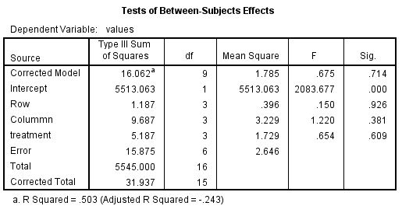

**Testing procedure:**

**Setting up Hypothesis**

H0: There is no significance difference between rows, columns and

treatments

H1: There is significance difference between rows, columns and treatments

**Level of significance**

α=0.05

**Decision**

For row, p = 0.926 > α = 0.05, Hence we accept H0 and H1 is rejected.

For column, p = 0.381> α = 0.05, Hence we accept H0 and H1 is rejected.

For treatment, p = 0.609 >α = 0.05, Hence we accept H0 and H1 is rejected.

**Conclusion:**

Hence, we conclude that there is no significant difference between rows

Columns and treatment.